Holy Trinity Evangelical Lutheran Church

19th Sunday After Pentecost

October 4 2026, at 10:30 am

Lay Speaker, James Stockert

*Prelude

* welcome and Announcements Worship Assistant

*Opening Hymn "When I Survey the Wondrous Cross" ELW 803
Public Domain
1.When I survey the wondrous cross on which the prince of
glory died, my richest gain I count but loss and pour contempt
on all my pride.

2.Forbid it, Lord, that I should boast save in the death of Christ,
my God; all the vain things that charm me most, I sacrifice them to his blood.

3.See, from his head, his hands, his feet, sorrow and love flow
mingled down. Did e’er such love and sorrow meet, or thorns compose so rich a crown?

4.Were the whole realm of nature mine, that were a present far
too small; love so amazing, so divine, demands my soul, my
life, my all.

* Confession and Forgiveness Worship Assistant
Blessed be the holy Trinity, ☩ one God, who pours love into our hearts and healing upon the earth. Amen.

Confident that God justifies us by grace through faith, let us confess our sin.

Compassionate God, we confess that we struggle to embody your goodness in the world and in our own hearts. Creation groans from overuse. Jealousy and bitterness strain our relationships. Divisions disrupt your call to show genuine love to others. Turn our hearts back to you. Restore our world and reconcile us to one another. Renew us to live as your holy people, following the way of Jesus Christ. Amen.

Hear this good news: We have peace with God through ☩ Jesus Christ, in whom there is no condemnation, but only forgiveness and the promise of eternal life. Receive freely this healing gift of grace. Amen.

* Canticle of Praise “Change My Heart, O God” ELW 801
CCLI-11222261
Change my heart, O God; make it ever true.
Change my heart, O God; may I be like you.
You are the potter; I am the clay.
mold me and make me; this is what I pray.

*Greeting Worship Assistant
The Grace of our Lord, Jesus Christ, the love of God and the communion of the holy Spirit be with you all. And also with you.

*Prayer of the Day Worship Assistant
Beloved God, from you come all things that are good. Lead us by the inspiration of your Spirit to know those things that are right, and by your merciful guidance, help us to do them, through Jesus Christ, our Savior and Lord. Amen.

*Passing of the Peace Worship Assistant
May the peace of christ be with you always. and also with you.

Please share the peace of christ with one another with a wave.

*NO Children’s Moment today
*First Lesson: Exodus 20:1-4, 7-9, 12-20 Reader
¹ God spoke all these words,
² “I am the Lord your God, who brought you out of the land of Egypt, out of the house of slavery; ³ you shall have no other gods before me.
⁴ “You shall not make for yourself an idol, whether in the form of anything that is in heaven above or that is on the earth beneath or that is in the water under the earth.
⁷ “You shall not make wrongful use of the name of the Lord your God, for the Lord will not acquit anyone who misuses his name.
⁸ “Remember the Sabbath day and keep it holy. ⁹ Six days you shall labor and do all your work.
¹² “Honor your father and your mother, so that your days may be long in the land that the Lord your God is giving you.
¹³ “You shall not murder.
¹⁴ “You shall not commit adultery.
¹⁵ “You shall not steal.
¹⁶ “You shall not bear false witness against your neighbor.
¹⁷ “You shall not covet your neighbor’s house; you shall not covet your neighbor’s wife, male or female slave, ox, donkey, or anything that belongs to your neighbor.”
¹⁸ When all the people witnessed the thunder and lightning, the sound of the trumpet, and the mountain smoking, they were afraid and trembled and stood at a distance ¹⁹ and said to Moses, “You speak to us, and we will listen, but do not let God speak to us, lest we die.” ²⁰ Moses said to the people, “Do not be afraid, for God has come only to test you and to put the fear of him upon you so that you do not sin.”

The Word of the Lord. Thanks be to God.

*Psalm 19 Reader
¹ The heavens are telling the glory of God,
and the firmament proclaims his handiwork.
² Day to day pours forth speech,
and night to night declares knowledge.
³ There is no speech, nor are there words;
their voice is not heard;
⁴ yet their voice goes out through all the earth
and their words to the end of the world.
In the heavens he has set a tent for the sun,
⁵ which comes out like a bridegroom from his wedding canopy,
and like a strong man runs its course with joy.
⁶ Its rising is from the end of the heavens
and its circuit to the end of them,
and nothing is hid from its heat.
⁷ The law of the Lord is perfect, reviving the soul;
the decrees of the Lord are sure, making wise the simple;
⁸ the precepts of the Lord are right, rejoicing the heart;
the commandment of the Lord is clear, enlightening the eyes;
⁹ the fear of the Lord is pure, enduring forever;
the ordinances of the Lord are true and righteous altogether.
¹⁰ More to be desired are they then gold, even much fine gold;
sweeter also than honey and drippings of the honeycomb.
¹¹ Moreover, by them is your servant warned;
in keeping them there is great reward.
¹² But who can detect one’s own errors?
Clear me from hidden faults.
¹³ Keep back your servant also from the insolent;
do not let them have dominion over me.
Then I shall be blameless and innocent of great transgression.
¹⁴ Let the words of my mouth and the meditation of my heart
be acceptable to you, O Lord, my rock and my redeemer.

*Second Lesson: Philippians 1:4b-14 Reader
[Paul writes:] ^{4b} If anyone else has reason to be confident in the flesh, I have more: ⁵ circumcised on the eighth day, a member of the people of Israel, of the tribe of Benjamin, a Hebrew born of Hebrews; as to the law, a Pharisee; ⁶ as to zeal, a persecutor of the church; as to righteousness under the law, blameless.
⁷ Yet whatever gains I had, these I have come to regard as loss because of Christ. ⁸ More than that, I regard everything as loss because of the surpassing value of knowing Christ Jesus my Lord. For his sake I have suffered the loss of all things, and I regard them as rubbish, in order that I may gain Christ ⁹ and be found in him, not having a righteousness of my own that comes from the law but one that comes through faith in Christ, the righteousness from God based on faith. ¹⁰ I want to know Christ and the power of his resurrection and the sharing of his sufferings by becoming like him in his death, ¹¹ if some-how I may attain the resurrection from the dead.
¹² Not that I have already obtained this or have already reached the goal, but I press on to lay hold of that for which Christ has laid hold of me. ¹³ Brothers and sisters, I do not consider that I have laid hold of it, but one thing I have laid hold of: forgetting what lies behind and straining forward to what lies ahead, ¹⁴ I press on toward the goal, toward the prize of the heavenly call of God in Christ Jesus.
The Word of the Lord. Thanks be to God.

* Acclamation “Alleluia” ELW pg. 205
Al-le-lu-ia! Lord and Savior: open now your saving word.
Let it burn like fire within us; speak until our hearts are stirred.
Al-le-lu-ia! Lord, we sing for the good news that you bring.

* Gospel: Matthew 21:33-46 Lay Speaker, James Stockert
The Holy Gospel according to Matthew, the 21st chapter. Glory to you, O Lord.
[Jesus said:] ³³ “Listen to another parable. There was a landowner who planted a vineyard, put a fence around it, dug a winepress in it, and built a watchtower. Then he leased it to tenants and went away. ³⁴ When the harvest time had come, he sent his slaves to the tenants to collect his produce. ³⁵ But the tenants seized his slaves and beat one, killed another, and stoned another. ³⁶ Again he sent other slaves, more than the first, and they treated them in the same way. ³⁷ Then he sent his son to them, saying, ‘They will respect my son.’ ³⁸ But when the tenants saw the son, they said to themselves, ‘This is the heir; come, let us kill him and get his inheritance.’ ³⁹ So they seized him, threw him out of the vineyard, and killed him. ⁴⁰ Now when the owner of the vineyard comes, what will he do to those tenants?” ⁴¹ They said to him, “He will put those wretches to a miserable death and lease the vineyard to other tenants who will give him the produce at the harvest time.”
⁴² Jesus said to them, “Have you never read in the scriptures:
‘The stone that the builders rejected
has become the cornerstone;
this was the Lord’s doing,
and it is amazing in our eyes’?
⁴³ “Therefore I tell you, the kingdom of God will be taken away from you and given to a people that produces its fruits. ⁴⁴ The one who falls on this stone will be broken to pieces, and it will crush anyone on whom it falls.”
⁴⁵ When the chief priests and the Pharisees heard his parables, they realized that he was speaking about them. ⁴⁶ They wanted to arrest him, but they feared the crowds, because they regarded him as a prophet.

The Gospel of the Lord. Praise to you, O Christ.

*Sharing Lay Speaker, James Stockert
* Hymn of the Day "Savior, Like a Shepherd lead us" ELW 789
Public Domain
1.Savior like a shepherd lead us; much we need your tender care. In your pleasant pastures feed us, for our use your fold prepare. Blessed Jesus, blessed Jesus, you have bought us; we are yours. Blessed Jesus, blessed Jesus, you have bought us; we are yours.

2.We are yours; in love befriend us, be the guardian of our way;
keep your flock, from sin defend us, seek us when we go astray.
Blessed Jesus, blessed Jesus, hear us children when we pray.
Blessed Jesus, blessed Jesus, hear us children when we pray.
3.You have promised to receive us, poor and sinful though we be; you have mercy to relieve us, grace to cleanse, and pow’r
to free. Blessed Jesus, blessed Jesus, early let us turn to you.
Blessed Jesus, blessed Jesus, early let us turn to you.

4.Early let us seek your favor, early let us do your will;
blessed Lord and only Savior, with your love our spirits fill.
Blessed Jesus, blessed Jesus, you have loved us, love us still.
Blessed Jesus, blessed Jesus, you have loved us, love us still.

* Apostle’s Creed Worship Assistant
Let us proclaim our faith with the words of the apostle’s creed.
I believe in God, the Father almighty,
creator of heaven and earth.
I believe in Jesus Christ, God's only Son, our Lord,
who was conceived by the power of the Holy Spirit,
born of the Virgin Mary,
suffered under Pontius Pilate,
was crucified, died, and was buried;
he descended to the dead.
On the third day he rose again;
he ascended into heaven,
he is seated at the right hand of the Father,
and he will come to judge the living and the dead.
I believe in the Holy Spirit,
the holy catholic Church,
the communion of saints,
the forgiveness of sins,
the resurrection of the body,
and the life everlasting. Amen.

* Prayers of Intercession Worship Assistant
Be Seated
Prayer Requests or Joys to share
Reminded of God’s gracious and abundant love, we offer our prayers, confident that God hears us.

God of every generation, we give thanks for all who have sought to renew and transform your holy church (especially Theodor Fliedner, re-newer of society). Inspire us to follow their example in our own day. Hear us, O God. Your mercy is great.

God of every creature, bless and protect the earth and all those who dwell within it. We give thanks for those who have helped us to see your Spirit in creation (especially Francis of Assisi, re-newer of the church). Hear us, O God. Your mercy is great.

God of every tribe and nation, restore peace to the world’s conflict zones (regions in crisis may be named), and shelter those who live within them. We pray especially for the safety of displaced people and refugees. Hear us, O God. Your mercy is great.

God of every comfort, you made us in your own image. Grant healing and relief to all who are sick or suffering (especially). Hear us, O God. Your mercy is great.

God of every truth, you draw us nearer to you through your holy word. We give thanks for teachers of the faith (congregational formation ministries may be named). Fill their hearts with your Spirit, that they inspire others with your truth. Hear us, O God. Your mercy is great.

God of every soul, you are the one who calls us home. We give thanks for all the saints who have been restored to perfect unity with you (especially). Hear us, O God. Your mercy is great.

Grant the prayers we have offered, what we have forgotten to ask, and whatever else you see that we need. We ask this in Jesus’ name. Amen.

*Offering Worship Assistant
The monthly mission for october is for “Outreach – Holiday baskets. Let us give to god what he has first given us.

*Offering music by Jared
*Offering Hymn "Glory to God, Whose Goodness Shines" ACS 1087
One License – A-700000
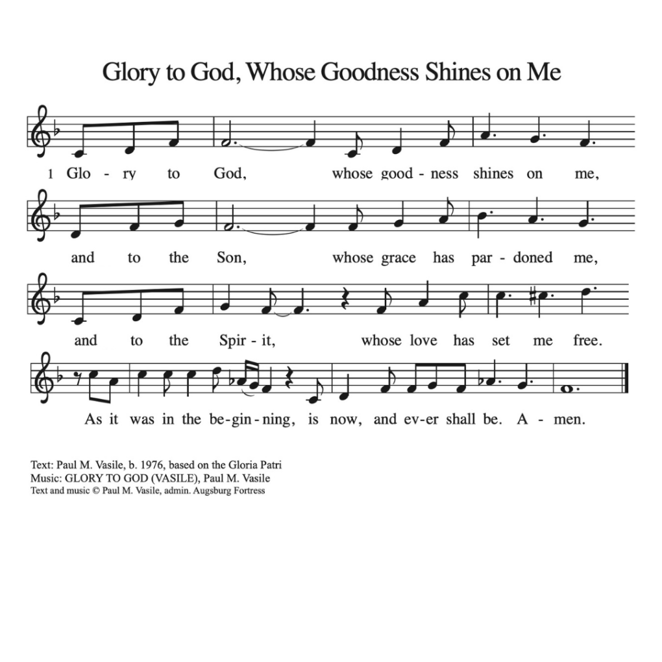

* Offering Prayer Worship Assistant and Congregation
God of creation, you send rain and the earth springs forth abundantly. All blessings are from you; make us generous with what we have. Use our gifts, our abilities, and our hearts in service to you and in love to our neighbors, today and always. Amen.

* Lord’s Prayer Worship Assistant
Gathered into one by the holy spirit, let’s pray as jesus taught us to pray.
Our father, who art in heaven, hallowed be thy name, thy kingdom come, thy will be done, on earth as it is in heaven. give us this day our daily bread; and forgive us our trespasses, as we forgive those who trespass against us; and lead us not into temptation, but deliver us from evil. for thine is the kingdom, and the power and the glory, forever and ever. Amen.
* Blessing Worship Assistant
The love of God abound in you; the grace of our savior jesus christ fill your hearts; and the life of the spirit + bless you and give your peace. amen.

* Closing Hymn "Amazing Grace" ELW 779
Public Domain
1.Amazing grace! How sweet the sound that saved a wretch like
me! I once was lost, but now am found; was blind, but now I see.

2.’Twas grace that taught my heart to fear, and grace my fears relieved; how precious did that grace appear the hour I first
believed!

3.Through many dangers, toils, and snares I have already come;
‘tis grace has brought me safe thus far, and grace will lead me home.

4.The Lord has promised good to me; his word my hope secures; he will my shield and portion be as long as life endures.

5.When we’ve been there ten thousand years, bright shining as the sun, we’ve no less days to sing God’s praise than when we’d
first begun.

* Dismissal Worship Assistant
Go out in joy. Be led forth in peace. Thanks be to God!

*Postlude

