Holy Trinity Evangelical Lutheran Church

17th Sunday After Pentecost

September 20, 2026 at 10:30 am

Lay Speaker, Bill Pim

*Prelude

* Welcome and Announcements Worship Assistant

*Opening Hymn "Lord of Light” ELW 688
One License A-700000 CCLI-11222261
1.Lord of light, your name outshining all the stars and
suns of space, use our talents in your kingdom as the
servants of your grace; use us to fulfill your purpose in
the gift of Christ your Son. Father, as in highest heaven,
so on earth your will be done.

2.By the toil of faithful workers in some far outlying field,
by the courage where the radiance of the cross is still
revealed, by the victories of meekness, through reproach
and suff’ring won: Father, as in highest heaven, so on earth
your will be done.

3.Grant that knowledge, still increasing, at your feet may
lowly kneel; with your grace our triumphs hallow, with
your charity our zeal; lift the nations from the shadows to the
gladness of the sun: Father, as in highest heaven, so on earth
your will be done.

4.By the prayers of faithful watchers, never silent day or night;
by the cross of Jesus, bringing peace to all and healing light;
by the love that passes knowledge, making all your children one:
Father, as in highest heaven, so on earth your will be done.

* Confession and Forgiveness lay Speaker, Bill Pim
Blessed be the holy Trinity, ☩ one God, who pours love into our hearts and healing upon the earth. Amen.

Confident that God justifies us by grace through faith, let us confess our sin.

Compassionate God, we confess that we struggle to embody your goodness in the world and in our own hearts. Creation groans from overuse. Jealousy and bitterness strain our relationships. Divisions disrupt your call to show genuine love to others. Turn our hearts back to you. Restore our world and reconcile us to one another. Renew us to live as your holy people, following the way of Jesus Christ. Amen.

Hear this good news: We have peace with God through ☩ Jesus Christ, in whom there is no condemnation, but only forgiveness and the promise of eternal life. Receive freely this healing gift of grace. Amen.

* Canticle of Praise “Change My Heart, O God” ELW 801
CCLI-11222261
Change my heart, O God; make it ever true.
Change my heart, O God; may I be like you.
You are the potter; I am the clay.
Mold me and make me; this is what I pray.

*Greeting lay Speaker, bill pim
The Grace of our Lord, Jesus Christ, the love of God and the communion of the Holy Spirit be with you all. and also with you.

*Prayer of the Day worship assistant
Almighty and eternal God, you show perpetual lovingkindness to us your servants. Because we cannot rely on our own abilities, grant us your merciful judgment, and train us to embody the generosity of your Son, Jesus Christ, our Savior and Lord. Amen.

*Passing of the Peace Worship Assistant
May the peace of Christ be with you always. and also with you.

Please share the sign of peace with one another with a wave.

Children’s Moment - pulpit prequel Lay Speaker, bill Pim

First Lesson: Jonah 3:10—4:11 Reader
¹⁰ When God saw what [the people of Ninevah] did, how they turned from their evil ways, God changed his mind about the calamity that he had said he would bring upon them, and he did not do it.
^{4:1} But this was very displeasing to Jonah, and he became angry. ² He prayed to the Lord and said, “O Lord! Is not this what I said while I was still in my own country? That is why I fled to Tarshish at the beginning, for I knew that you are a gracious and merciful God, slow to anger, abounding in steadfast love, and relenting from punishment. ³ And now, O Lord, please take my life from me, for it is better for me to die than to live.” ⁴ And the Lord said, “Is it right for you to be angry?” ⁵ Then Jonah went out of the city and sat down east of the city and made a booth for himself there. He sat under it in the shade, waiting to see what would become of the city.
⁶ The Lord God appointed a bush and made it come up over Jonah, to give shade over his head, to save him from his discomfort, so Jonah was very happy about the bush. ⁷ But when dawn came up the next day, God appointed a worm that attacked the bush, so that it withered. ⁸ When the sun rose, God prepared a sultry east wind, and the sun beat down on the head of Jonah so that he was faint and asked that he might die. He said, “It is better for me to die than to live.”
⁹ But God said to Jonah, “Is it right for you to be angry about the bush?” And he said, “Yes, angry enough to die.” ¹⁰ Then the Lord said, “You are concerned about the bush, for which you did not labor and which you did not grow; it came into being in a night and perished in a night. ¹¹ And should I not be concerned about Nineveh, that great city, in which there are more than a hundred and twenty thousand persons who do not know their right hand from their left and also many animals?”

The Word of the Lord. Thanks be to God.

Psalm 145:1-8 Reader
¹ I will extol you, my God and King,
and bless your name forever and ever.
² Every day I will bless you
and praise your name forever and ever.
³ Great is the Lord and greatly to be praised;
his greatness is unsearchable.
⁴ One generation shall extol your works to another
and shall declare your mighty acts.
⁵ They will recount the glorious splendor of your majesty,
and on your wondrous works I will meditate.
⁶ They will proclaim the might of your awesome deeds,
and I will declare your greatness.
⁷ They shall celebrate the fame of your abundant goodness
and shall sing aloud of your righteousness.
⁸ The Lord is gracious and merciful,
slow to anger and abounding in steadfast love.

Second Lesson: Ruth 1:21-30 Reader
²¹ For to me, living is Christ and dying is gain. ²² If I am to live in the flesh, that means fruitful labor for me, yet I cannot say which I will choose. ²³ I am hard pressed between the two: my desire is to depart and be with Christ, for that is far better, ²⁴ but to remain in the flesh is more necessary for you. ²⁵ Since I am convinced of this, I know that I will remain and continue with all of you for your progress and joy in faith, ²⁶ so that, by my presence again with you, your boast might abound in Christ Jesus because of me.
²⁷ Only, live your life in a manner worthy of the gospel of Christ, so that, whether I come and see you or am absent and hear about you, I will know that you are standing firm in one spirit, striving side by side with one mind for the faith of the gospel ²⁸ and in no way frightened by those opposing you. For them, this is evidence of their destruction but of your salvation. And this is God’s doing. ²⁹ For he has graciously granted you the privilege not only of believing in Christ but of suffering for him as well, ³⁰ since you are having the same struggle that you saw I had and now hear that I still have.
The Word of the Lord. Thanks be to God.

* Acclamation “Alleluia” ELW pg. 205
Al-le-lu-ia! Lord and Savior: open now your saving word.
Let it burn like fire within us; speak until our hearts are stirred.
Al-le-lu-ia! Lord, we sing for the good news that you bring.

* Gospel: Matthew 20:1-16 Lay Speaker, Bill Pim
The Holy Gospel according to Matthew, the 20th chapter. Glory to you, O Lord.
[Jesus said to the disciples:] ¹ “The kingdom of heaven is like a landowner who went out early in the morning to hire laborers for his vineyard. ² After agreeing with the laborers for a denarius for the day, he sent them into his vineyard. ³ When he went out about nine o’clock, he saw others standing idle in the marketplace, ⁴ and he said to them, ‘You also go into the vineyard, and I will pay you whatever is right.’ So they went. ⁵ When he went out again about noon and about three o’clock, he did the same. ⁶ And about five o’clock he went out and found others standing around, and he said to them, ‘Why are you standing here idle all day?’ ⁷ They said to him, ‘Because no one has hired us.’ He said to them, ‘You also go into the vineyard.’ ⁸ When evening came, the owner of the vineyard said to his manager, ‘Call the laborers and give them their pay, beginning with the last and then going to the first.’ ⁹ When those hired about five o’clock came, each of them received a denarius. ¹⁰ Now when the first came, they thought they would receive more; but each of them also received a denarius. ¹¹ And when they received it, they grumbled against the landowner, ¹² saying, ‘These last worked only one hour, and you have made them equal to us who have borne the burden of the day and the scorching heat.’ ¹³ But he replied to one of them, ‘Friend, I am doing you no wrong; did you not agree with me for a denarius? ¹⁴ Take what belongs to you and go; I choose to give to this last the same as I give to you. ¹⁵ Am I not allowed to do what I choose with what belongs to me? Or are you envious because I am generous?’ ¹⁶ So the last will be first, and the first will be last.”
The Gospel of the Lord. Praise to you, O Christ.

Sermon “That’s Not Fair!” Lay Speaker, Bill Pim
* Hymn of the Day "Take My Life, That I May Be" ELW 685 vs. 1 – 4
Public Domain
1.Take my life, that I may be consecrated, Lord, to thee;
take my moments and my days; let them flow in ceaseless praise.

2.Take my hands and let them move at the impulse of thy love;
take my feet and let them be swift and beautiful for thee.

3.Take my voice and let me sing always, only, for my King;
take my lips and let them be filled with messages from thee.

4.Take my silver and my gold, not a mite would I withhold;
take my intellect, and use ev’ry pow’r as thou shalt choose.

* Apostle’s Creed Worship Assistant
Let us proclaim our faith in the words of the Apostle’s creed.
I believe in God, the Father almighty,
creator of heaven and earth.
I believe in Jesus Christ, God's only Son, our Lord,
who was conceived by the power of the Holy Spirit,
born of the Virgin Mary,
suffered under Pontius Pilate,
was crucified, died, and was buried;
he descended to the dead.
On the third day he rose again;
he ascended into heaven,
he is seated at the right hand of the Father,
and he will come to judge the living and the dead.
I believe in the Holy Spirit,
the holy catholic Church,
the communion of saints,
the forgiveness of sins,
the resurrection of the body,
and the life everlasting. Amen.

* Prayers of Intercession Lay Speaker, Bill Pim
Be seated
prayer requests and joys to share
Reminded of God’s gracious and abundant love, we offer our prayers, confident that God hears us.

Hold your church accountable for our unwillingness to share your good news and our anger at your generosity to others. Nourish us by your grace to be witnesses to your love. Hear us, O God. Your mercy is great.

Guide scientists and researchers studying working to protect the environment so that all your creation may inspire us to give thanks for your great goodness. Hear us, O God. Your mercy is great.

Show employers the benefits of equal pay standards for all their employees. Reconcile conflicts between employees. Fill places of employment with camaraderie, and bring an end to employment disparity. Hear us, O God. Your mercy is great.

Encourage any who cannot work or who cannot work a full day with the truth that their value comes from your everlasting love for them. Provide for those who are injured, ill, and for all in any need (especially). Hear us, O God. Your mercy is great.

Strengthen all those in this congregation whose labor serves the needs of others in the community (especially). Inspire all in this congregation to support community endeavors with our time and talents. Hear us, O God. Your mercy is great.

Comfort us with the promise of the resurrection as we remember all our loved ones whose desire to be with Jesus is fulfilled. Hear us, O God. Your mercy is great.

Grant the prayers we have offered, what we have forgotten to ask, and whatever else you see that we need. We ask this in Jesus’ name. Amen.

Offering Worship Assistant
The Monthly Mission for September is “Faith In Action.” Let us give to God what He has first given us.

Special music by Jared

*Offering Hymn "Glory to God, Whose Goodness Shines" ACS 1087
One License A-700000
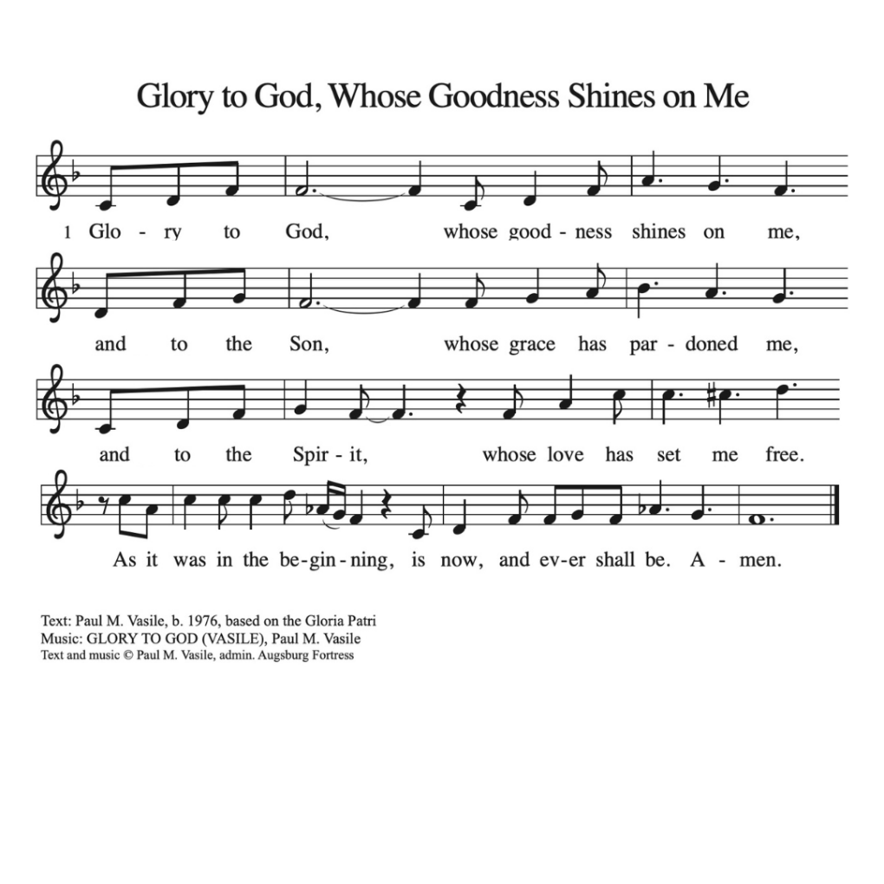

* Offering Prayer worship assistant
God of creation, you send rain and the earth springs forth abundantly. All blessings are from you; make us generous with what we have. Use our gifts, our abilities, and our hearts in service to you and in love to our neighbors, today and always. Amen.

* Lord’s Prayer Lay Speaker, Bill Pim ELW pg 208
Gathered into one by the holy spirit, let us pray the prayer jesus taught us:
Our Father, who art in heaven, hallowed be thy name, thy kingdom come, thy will be done, on earth as it is in heaven. give us this day our daily bread; and forgive us our trespasses, as
we forgive those who trespass against us; and lead us not into temptation, but deliver us from evil. for thine is the kingdom, and the power, and the glory, forever and ever. amen.
* Blessing lay speaker, bill pim
The God of love
draw you into full accord and one mind,
in the body of Christ Jesus.
Amen.
The God of hope
grant you strength and joy in all circumstances
through the interceding of the Spirit.
Amen.
The God of grace
☩ bless you now and forever.
Amen.

*Hymnology story Lay Speaker, Bill Pim

* Closing Hymn “Because He Lives” Blue Hymnal 358

1.God sent His Son, they called Him Jesus; He came to love,
heal and forgive. He lived and died to buy my pardon; an
empty grave is there to prove my Savior lives.
Because He lives I can face tomorrow; Because He lives, all
fear is gone. Because I know He holds the future, and life is worth the living just because he lives.

2.How sweet to hold a newborn baby, and feel the pride and
joy he gives; But greater still the calm assurance: This child
can face uncertain days because He lives. Because He lives I can face tomorrow; Because He lives, all fear is gone. Because I know He holds the future, and life is worth the living just because he lives.

3.And then one day I’ll cross the river, I’ll fight life’s final war with pain. And then, as death gives way to vict’ry, I’ll see the lights of glory and I’ll know He reigns. Because He lives, all
fear is gone. Because I know He Holds the future, and life is worth the living just because he lives.

* Dismissal
Go out in joy. Be led forth in peace. Thanks be to God!

*Postlude

